 | Your Community Health  Consumer Advisory Committee  Terms of Reference | Approval date: June 2019
 |  | Review Dates: March 2020
 |  | Next Review Due: March 2021
 |  | Page 1 of 3
Authorised by: Quality Committee

PURPOSE
Your Community Health works from the social model of health. We enable health, wellbeing and dignity for all people in northern Melbourne by providing responsive and accessible services. The Consumer Advisory Committee is an important part of our system of good governance for our organisation and the services it provides. Consumer input to Your Community Health is not confined to the Consumer Advisory Committee; the Committee operates at the organisational level of our CCCP Implementation Matrix and consumers also have input across the individual and service levels.
Our organisation is governed by a Board of Directors (the Board). Consumers are at the centre of the National Model Clinical Governance Framework:
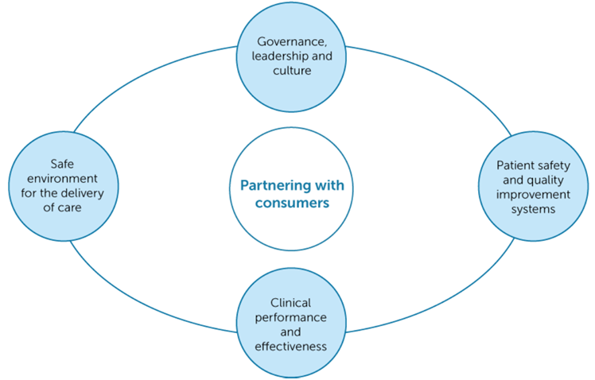

The Consumer Advisory Committee has been established by Your Community Health to:
- Provide advice to the Quality Committee
- Create opportunities for consumer involvement in subcommittees of the governing body, and
- Ensure consumer input to decisions of the governing body.
RELEVANT DEFINITIONS
Community: Groups of people with a shared interest, living, working and /or studying in northern Melbourne.
Consumers and Carers: People who are currently or potentially use Your Community Health services and programs.
Carers: family and friends providing unpaid support and care to consumers.
Diversity: Diversity is what makes an individual or group unique. Diversity is not just associated with one’s ethnic background. Diversity can be reflected in a number of ways including:

- ethnicity and race
- language
- gender
- sexual orientation
- age and generation
- socioeconomic status
- religion, faith and other beliefs.

Good governance: In the context of the complete set of NSQHS Standards, the Clinical Governance Standard and the Partnering with Consumers Standard together ensure the creation of clinical governance systems within healthcare organisations that:
- Are fully integrated within overall corporate governance systems
- Are underpinned by robust safety and quality management systems
- Maintain and improve the reliability, safety and quality of health care
- Improve health outcomes for patients.

Health: Good health is a state of complete physical, social and mental well-being, and not merely the absence of disease or infirmity. Health is a resource for everyday life, not the object of living, and is a positive concept emphasizing social and personal resources as well as physical capabilities.
Participation: occurs when consumers, carers and community members are meaningfully involved in decision-making about health policies and planning, care and treatment, and the wellbeing of themselves and the community. It is about having your say, thinking about why you believe in your views and listening to the views and ideas of others. In working together, decisions may include a range of perspectives.
Priority Groups: Your Community Health’s Strategic Directions 2017 – 2021 identify groups of people who are at risk of poorer health outcomes in accordance with the social determinants of health (see below). We prioritise access for:

- Aboriginal and Torres Strait Islander people
- People who are newly arrived refugees and asylum seekers
- Children under 12 ( with support to their parents or carers)
- Adults over 65
- People who are socioeconomically disadvantaged
- People with chronic or complex conditions
- People who live in unsafe or insecure environments
- People living with disability
Social Model of Health: Acknowledges the social, environmental and economic factors that affect health, as well as the biological and medical factors.
Social Determinants of Health: The social determinants of health are the conditions in which people are born, grow, live, work and age. These circumstances are shaped by the distribution of money, power and resources at global, national and local levels. One way Your Community Health responds to these determinants is by providing priority access to people who experience these factors i.e. Priority Groups.

MEMBERSHIP
The Consumer Advisory Committee will include:
- Five to eight community members who are current or potential consumers, and who reflect the diverse northern metropolitan Melbourne community
- Chief Executive Officer
- General Manager - Quality, Innovation and Integration
- Service Development Officer
The General Manager Quality, Innovation and Integration will chair the Consumer Advisory Committee, and meetings will be convened by the Service Development Officer.
TERMS
Consumer Advisory Committee members will be appointed by Your Community Health to a three year term. Before the appointed term has expired, Committee members are able to request re-appointment to a further 3 year term, with the maximum number of terms to be served consecutively being three i.e. 3 X 3 year terms.
If positions become vacant, Your Community Health is able to appoint community members to the remaining period of that term, after which the same process for re-appointment applies as to other Committee members.
MEETINGS
The Consumer Advisory Committee will meet at least bimonthly, or as otherwise agreed by the Committee. The Committee may schedule additional sub-committee meetings for the purpose of a working group.
The Agenda and supporting papers will be sent to members at least one week in advance of each meeting.
A quorum for any full Committee meeting will be three community members and the CEO (or delegate) and a Your Community Health staff member as a minimum. Resolutions will require a simple majority.
Conflicts of interest will be managed and privacy and confidentiality maintained in accordance with the Your Community Health Committee and Volunteer Confidentiality and Code of Conduct Agreement.

REPORTING
The Consumer Advisory Committee will report quarterly to the Quality Committee through its Chairperson or delegate, raising issues for consideration or making appropriate recommendations for approval by the Board. Members of the Quality Committee may be invited to attend Consumer Advisory Committee meetings.

RESPONSIBILITIES

The responsibilities of the Consumer Advisory Committee members are to:
- Participate in orientation or other induction and development activities as invited and subject to member availability
- Prepare for and attend scheduled meetings and undertake agreed actions or follow-up
- Attend at least 75% (or four out of six) meetings scheduled each year, unless otherwise agreed
- Notify Your Community Health if they are unable to attend a meeting (put in an apology)
- Progress and monitor the directions of the Committee as agreed in the Consumer Advisory Committee Workplan/Meeting Schedule
- Work constructively with others on the Consumer Advisory Committee and Your Community Health
- Express consumer opinions, perspectives and views as an individual, not as a representative of an organisation
- Provide feedback and advice to Your Community Health, using their consumer and community experience
- Undertake required quality checks and procedures such as National Police Check, Working With Children’s Check, Disability Worker Exclusion Scheme, Your Community Health Confidentiality and Code of Conduct Agreement – Consumer Committees and Working Groups
- Uphold the values of Your Community Health.

The responsibilities of Your Community Health are to:
- Provide a minimum of one week’s notice of meetings to all members
- Send members the meeting agenda and meeting papers one week prior to meetings
- Support members to attend and participate in meetings e.g. transport, interpreters or other assistance required to meet individuals’ needs and is agreed
- Assist members to understand the role of the Committee
- Support members to understand meeting papers and documents provided in meetings, and the meeting process
- Provide information in a way that meets the needs of individual Committee members
- Provide the Committee with feedback and outcomes of their advice, including an explanation of why their advice has not been followed if this occurs
- Uphold the values of Your Community Health.

REVIEW
In order to ensure that the Consumer Advisory Committee is fulfilling its duties in accordance with these Terms of Reference, the Committee will:
- Be provided with agreed training and support
- At least annually, formally discuss its performance against the requirements of the Terms of Reference and the Committee’s annual Workplan, and report the outcomes of this assessment to the Quality Committee
- Be provided with timely feedback where relevant, and at least annually obtain feedback from the Quality Committee and Board regarding the Consumer Advisory Committee’s performance and implement any agreed actions
- Review the Terms of Reference when due, and recommend required changes to the Quality Committee and Board for approval.

Page 7, National Model Clinical Governance Framework, Australian Commission on Safety and Quality in Health Care 2017
Page 18, National Model Clinical Governance Framework, Australian Commission on Safety and Quality in Health Care 2017
Dreachslin, J., Gilbert, M., & Malone, B. (2012). Diversity and Cultural Competence in Health Care : A systems approach (1 ed.). Hoboken, NJ: Wiley. Cited in PCC4U, Australian Government Department of Health, viewed as at 1/2/18 http://www.pcc4u.org/learning-modules/focus-topics/topic-4-culture-centred-care/1-diversity-in-contemporary-australian-society/activity-1-diversity-in-australia-health-care/
National Safety and Quality in Health Service Standards (2nd edition): viewed as at 31/1/18 https://www.safetyandquality.gov.au/wp-content/uploads/2017/12/National-Safety-and-Quality-Health-Service-Standards-second-edition.pdf
Page 6 National Model Clinical Governance Framework, Australian Commission on Safety and Quality in Health Care 2017. Your Community Health used the term ‘consumer’ rather than ‘patient’.
Preamble to the Constitution of the World Health Organization (WHO) as adopted by the International Health Conference, New York, 19 June - 22 July 1946; signed on 22 July 1946 by the representatives of 61 States (Official Records of the World Health Organization, no. 2, p. 100) and entered into force on 7 April 1948. The definition has not been amended since 1948.
The Ottawa Charter for Health Promotion: viewed as at 31/1/18 http://www.who.int/healthpromotion/conferences/previous/ottawa/en/
Department of Health, Victoria, Australia, Primary and Community Health: viewed as at 31/1/18: http://www.health.vic.gov.au/pch/commhealth/
WHO, Social Determinants of Health webpage viewed 31/1/18: http://www.who.int/social_determinants/en/

